|  |
| --- |
| Set 4O |
| Assignment 1 |
| Comp 4985 |
|  |
| **Mateusz Siwoski A00758640** |
| **1/15/2014** |

|  |
| --- |
|  |

Design:

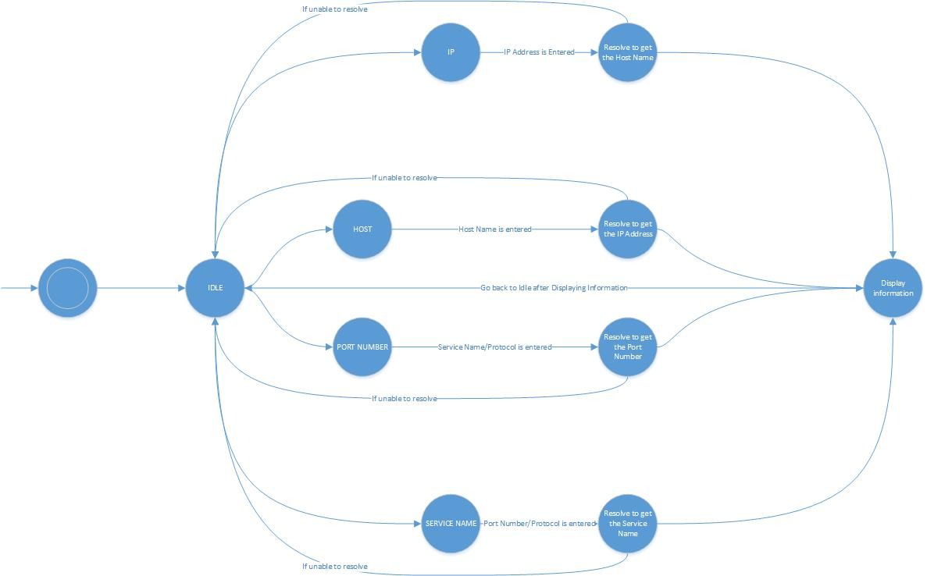

Psuedocode:

Int winMain (HINSTANCE, HINSTANCE, LPSTR, int){  
 Register the window  
 Create the Window  
 Read for and Deal with the MSG type  
}  
Bool Register(HINSTANCE){  
 Set the types for the WNDCLASS struct  
 Register the class/Window  
}  
HWND Create(HINSTANCE, int){

Create the window  
 Malloc for the Struct that will be specific to the window  
 Malloc any structs within the struct that will be used  
}

LRESULT CALLBACK WndProc (HWND, UINT Message, WPARAM, LPARAM){

Message Crackers for WM_CREATE, WM_COMMAND, WM_DESTROY, WM_PAINT  
}

BOOL Window_OnCreate(HWND) {

Call WSAStartup   
}

void Window_OnCommand (HWND, int, HWND, UINT) {

if IP is entered:

Malloc struct for the IP Address  
 If the WSAAsyncGetHostByAddr passes

Store info in struct

Else

Error Msg

if Host Name is entered:   
 If the WSAAsyncGetHostByName passes

Store info in struct

Else

Error Msg

if the Service Name and Protocol type is entered:  
 If the WSAAsyncGetHostByAddr passes

Store info in struct

Else

Error Msg

if the Port Number and Protocol type is entered:   
 If the WSAAsyncGetHostByAddr passes

Store info in struct

Else

Error Msg  
}

void Window_onPaint(HWND) {

Check the information in the struct

Display the information if it is in the struct  
}

void Window_OnDestroy (HWND) {

WSACleanup  
 Close the window  
}

BOOL CALLBACK IPDlgProc (HWND, UINT message, WPARAM, LPARAM) {

Open the Dialog Box  
 Get the IP Address and store information in struct  
 Pass the information in the struct to the wndProc   
}

BOOL CALLBACK HostDlgProc (HWND, UINT message, WPARAM, LPARAM) {

Open the Dialog Box  
 Get the Host name & store information in struct

Pass the information in the struct to the wndProc  
}

BOOL CALLBACK PortNumDlgProc (HWND, UINT message, WPARAM, LPARAM) {  
 Open a Dialog Box  
 Get the Service Name & store information in Struct

Get the Protocol Type & store information in Struct

Pass the information in the struct to the wndProc  
}

BOOL CALLBACK ServiceNameDlgProc (HWND, UINT message, WPARAM, LPARAM) {

Open a dialog Box  
 Get the Port Number & store information in Struct  
 Get the Protocol Type & store information in Struct

Pass the information in the struct to the wndProc   
}

# Test Cases:

|  |  |  |  |  |  |  |  |  |
| --- | --- | --- | --- | --- | --- | --- | --- | --- |
|  |  |  |  |  |  |  |  |  |
| **Test** | **Tests Description** | | **Tools Used** | **Expected Result** | **Pass/Fail** | **Notes** | | |
| 1 | Open an Initial Window | | Windows Protocol | The initial window should open with the menu options | Pass | See Figure 1 | | |
| 2 | Get a Host Name by IP Address | | Windows Protocol | A dialog box to enter an IP Address should open and when OK is pressed, the Host Name Appears and any Aliases appear | Pass | See Figure 2a/2b | | |
| 3 | Get an IP Address by Host Name | | Windows Protocol | A dialog box to enter an Host Name appears and when OK is pressed, the IP Address Appears and any Aliases appear | Pass | See Figure 3a/3b | | |
| 4 | Get A Port Number by Service Name and Protocol Type | | Windows Protocol | A dialog box to enter an IP Address appears and when OK is pressed, the Port Number, Service Name and Protocol Type appear | Pass | See Figure 4a/4b | | |
| 5 | Get a Service Name by Port Number and Protocol Type | | Windows Protocol | A dialog box to enter an IP Address appears and when OK is pressed, the Port Number, Service Name and Protocol Type appear | Pass | See Figure 5a/5b | | |

# Figures:

Figure 1: Open an Initial Window)

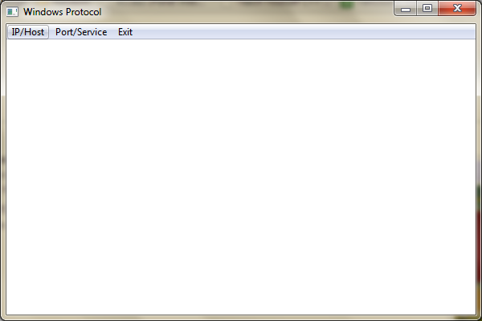

Figure 2a: Get a Host Name by IP Address)

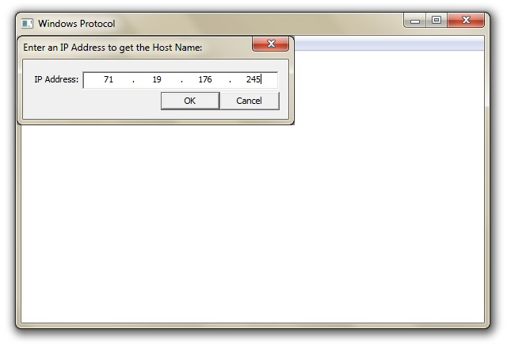

Figure 2b: Get a Host Name by IP Address)

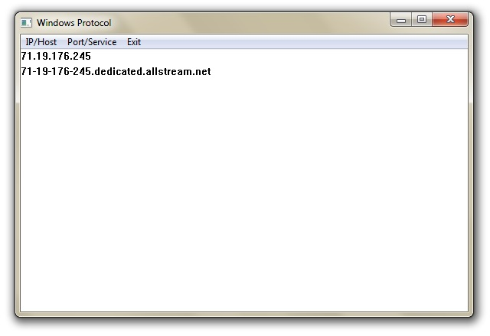

Figure 3a: Get an IP Address by Host Name)

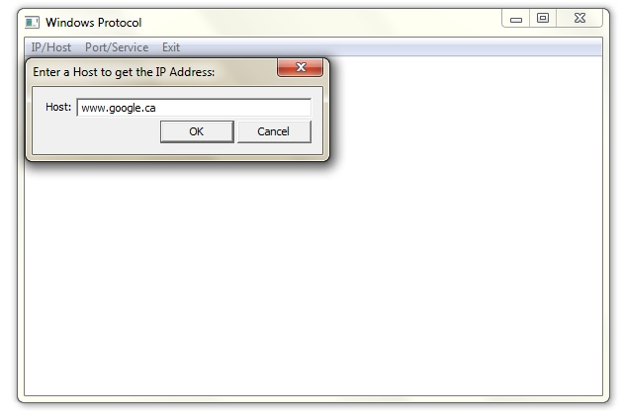

Figure 3b: Get an IP Address by Host Name)

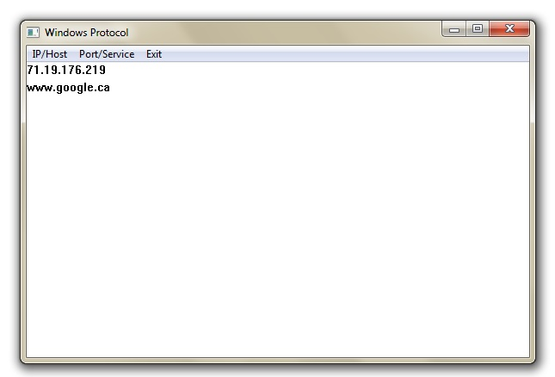

Figure 4a: Get A Port Number by Service Name and Protocol Type)

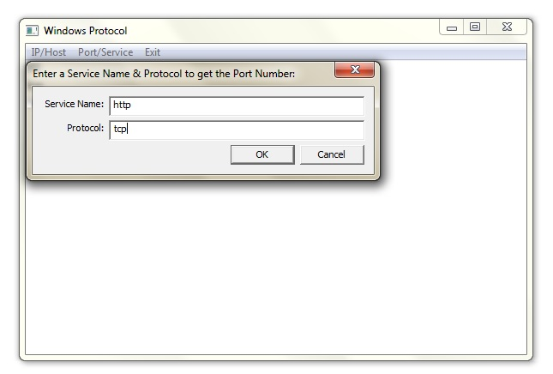

Figure 4b: Get a Port Number by Service Name and Protocol Type)

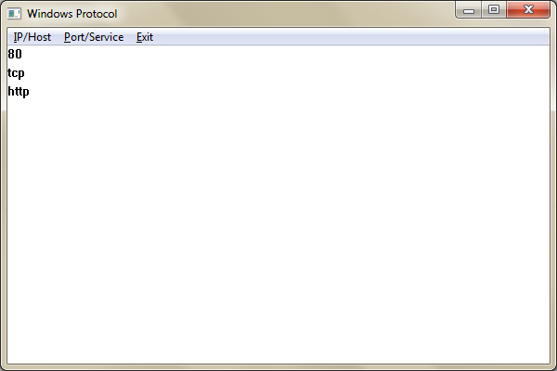

Figure 5a: Get a Service Name by Port Number and Protocol Type)

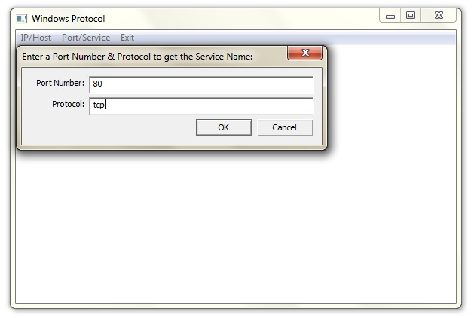

Figure 5b: Get a Service Name by Port Number and Protocol Type)

